CATHOLIC JUNIOR COLLEGE

CHEMISTRY 8872/01
Higher 1

Paper 1 Multiple Choice
JC 2 Preliminary Examinations
17th September 2010

50 minutes

Additional Materials: Multiple Choice Answer Sheet
Soft clean eraser
Soft pencil (type B or HB is recommended)
Data Booklet

READ THESE INSTRUCTIONS FIRST

Write in soft pencil.
Do not use paper clips, highlighters, glue or correction fluid.
Write and shade your name, class and NRIC / FIN on the Answer Sheet.

There are thirty questions in this paper. Answer all questions. For each question there are four possible answers A, B, C and D.
Choose the one you consider correct and record your choice in soft pencil on the separate Answer Sheet.

Read the instructions on the Answer Sheet very carefully.

Each correct answer will score one mark. A mark will not be deducted for a wrong answer.
Any rough working should be done in this booklet.
You may use a calculator.

There are a total of 12 printed pages.

Section A
For each question there are four possible answers, A, B, C and D. Choose the one you consider to be correct.

1 Which of the following statements about 1 mol of a metal is correct?

A It is liberated by 1 mol of electrons.
B It has the same mass as 1 mol of hydrogen atoms.
C It has the same number of atoms as 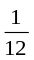 mol of ¹²C.
D It contains the same number of atoms as 1 mol of hydrogen atoms.

- 10 cm³ of a gaseous hydrocarbon was completely burnt in 100 cm³ of oxygen. The volume of gas obtained after reaction was 80 cm³. When the gas was shaken with aqueous sodium hydroxide, the volume decreased to 20 cm³.
Which one of the following represents the structure of the hydrocarbon? (All volumes are measured at the same temperature and pressure, and water is produced.)

A | 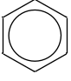 | B | 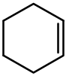
C | 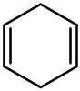 | D | 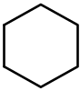

- Gaseous particle X has a proton number n and a charge of +1.
Gaseous particle Y has a proton number of (n+1) and is isoelectronic with X.
X and Y have the same number of neutrons.
Which one of the following statements that describes X and Y is incorrect?
A The ionic charge on X is half that on Y.
B X has a larger ionic radius than Y.
C X requires less energy than Y when an electron is removed from each particle.
D X will be deflected by a larger magnitude than Y when each particle is passed through an electric field.

- Which of the following groups contains species with linear, trigonal pyramidal and tetrahedral shapes?
A | CO₂ | SO₂ | NH₃
B | HCN | H₃O⁺ | SiCl₄
C | SiCl₄ | NH₃ | H₃O⁺
D | CO₂ | HCN | H₃O⁺

- The following graph is obtained when a certain property was plotted against atomic number.
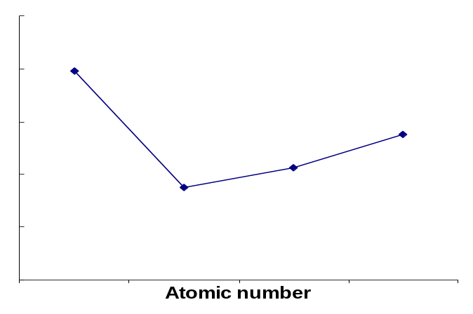
Which property when plotted against atomic number gives the shape of the above graph?
A Boiling points of HF, HCl, HBr and HI.
B Melting points of Na, Mg, Al and Si.
C Electronegativity of N, O, F and Ne.
D Ionic radius of Cl—, Na⁺, Mg²⁺ and Al³⁺.

- Which of the following features will contribute to a significant degree of covalent character in an ionic compound?
A Large cationic radius.
B Small anionic radius.
C Large cationic charge.
D Small anionic charge.

- Element X is a solid with a very low electrical conductivity at room temperature. It forms only one chloride, which is a liquid at room temperature and is a non-conductor of electricity. The chloride hydrolyses in water forming a white solid and a strongly acidic solution.
Which of the following could be X?
A Aluminium B Phosphorus
C Silicon D Sulfur

- The standard enthalpy change of the following reaction is -896.4 kJ mol⁻¹.
2HN₃(l) + 2NO(g) → H₂O₂(l) + 4N₂(g)

 | NO (g) | H₂O₂ (g)
ΔH^{θ}_{f}/kJ mol⁻¹ | + 90.3 | - 187.8

Using the given information in the above table, what is the standard enthalpy change of formation, in kJ mol⁻¹, of HN₃(l)?
A +264 B +528 C +618 D +632
- Which equation correctly describes the reaction whose ΔH is the standard enthalpy change of formation of water at 298 K?
A H⁺(aq) + OH⁻(aq) → H₂O(l)
B H₂(g) + O₂(g) → H₂O(g)
C H₂(g) + O₂(g) → H₂O(l)
D 2H(g) + O(g) → H₂O(l)

- Using a colorimeter, the following reaction is studied by finding the time taken for a coloured reactant, A, to decolourise. The reaction is catalysed by Y.
Y
A + B C + D
The following results are obtained:
Expt no. | Vol. of A added/ cm³ | Vol. of B added/ cm³ | Vol. of Y added/ cm³ | Vol. of H₂O added/ cm³ | Time taken/ s
1 | 10 | 20 | 10 | 10 | 20
2 | 10 | 10 | 10 | 20 | 40
3 | 10 | 20 | 5 | 15 | 40
4 | 5 | 20 | 10 | 15 | 40

What is the rate equation for the reaction?
A rate = k[B][Y] B rate = k[A][B]
C rate = k[A][Y] D rate = k[A][B][Y]

- Lead is the final product formed by a series of changes in which the slowest step is the radioactive decay of uranium-238. This radioactive decay is a first order reaction with rate constant of 1.54 x 10⁻¹⁰ year⁻¹.
What would be the age of a rock sample, originally lead-free, in which the molar proportion of uranium to lead is now 1:15?
A 2.25 x 10⁹ years B 9.00 x 10⁹ years
C 1.35 x 10¹⁰ years D 1.80 x 10¹⁰ years
- The following reaction is one of the steps involved in the manufacture of sulfuric acid.
2 SO₂(g) + O₂(g) ⇌ 2 SO₃(g) ΔH = -197 kJ mol⁻¹
The operating conditions are:
Temperature: | 450 – 550 ºC
Pressure: | 10 atm
Catalyst: | V₂O₅ catalyst

Which factor influences the choice of these conditions?
A The V₂O₅ catalyst increases the equilibrium yield of SO₃.
B At lower temperature, the rate of formation of SO₃ increases.
C At lower temperature, the equilibrium yield of SO₃ increases.
D At lower pressures, the rate of formation of SO₃ increases.

- When calcium carbonate is heated in a closed vessel, it dissociates to calcium oxide and carbon dioxide according to the following equation.
CaCO₃(s) ⇌ CaO(s) + CO₂(g)
Which of the following gives the correct expression for the equilibrium constant, K_{c}?
A | K_{c} = 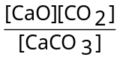 | B | K_{c} = 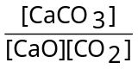
C | K_{c} = [CO₂] | D | K_{c} = 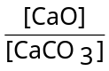

- NH₄⁺(aq) + NaOH(aq) → NH₃(g) + H₂O(l) + Na⁺(aq)
Which one of the following is true for the above reaction?
A Nitrogen in NH₄⁺ is oxidised.
B NH₄⁺ is behaving as a base.
C Phenolphthalein can be used as an indicator for the titration.
D The H-N-H bond angle in NH₄⁺ is smaller than that in NH₃.

Temperature / K | K_{w} / mol² dm⁻⁶
289 | 5 x 10⁻¹⁵
298 | 1 x10⁻¹⁴

Which of the following can be used to explain this difference in K_{w} values?
A H⁺(aq) and OH⁻(aq) are formed through endothermic reaction.
B Formation of H⁺(aq) and OH⁻(aq) is favoured at lower temperatures.
C The pH of water is independent of the temperature.
D The concentration of water is lower at higher temperature.
- Vitamin C has the following structure.

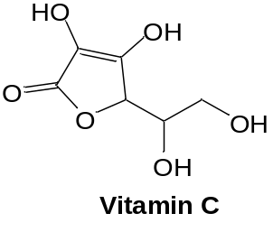

Which of the following shows the correct hybridisation of the carbon atoms?
sp² sp³
A 6 0
B 4 2
C 3 3
D 2 4

- An alkene can exist as a pair of geometric isomers. When refluxed with hot, concentrated acidified potassium manganate(VII), no effervescence was observed.
Which of the following correctly shows the structure of the alkene?

A B
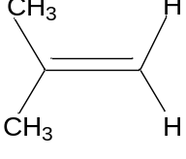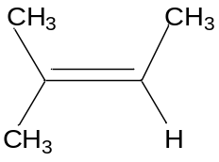

C D
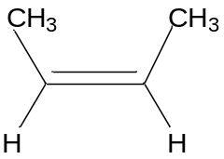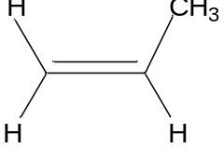

- 4-propylbenzoic acid has the following structure.

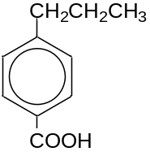

Which of the following pairs of structures correctly shows the major products formed when 4-propylbenzoic acid is reacted with bromine with iron powder as a catalyst in the dark?

A
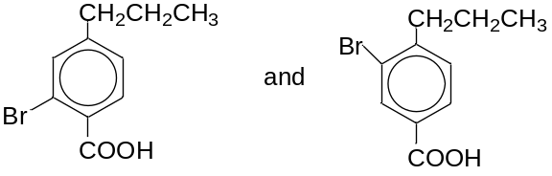
B
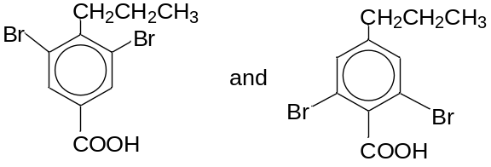
C
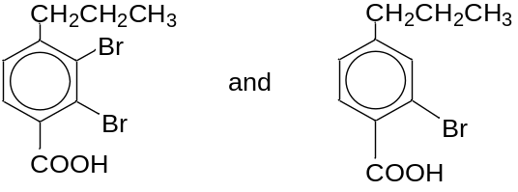
D
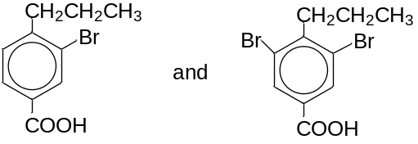

- 2-bromo-2-chloro-1-fluoroethylbenzene has the structure below.

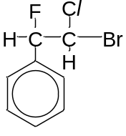
Which of the following shows the correct structure when it is refluxed with aqueous potassium hydroxide?

A B
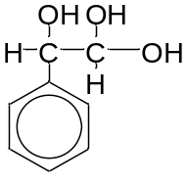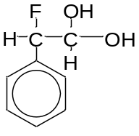

C D
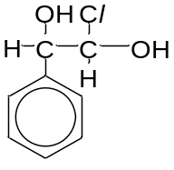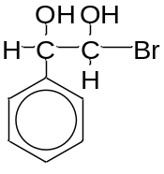

- 2-hydroxypropanoic acid can be synthesised from ethanal via an intermediate Y:
CH₃CHO → Y → CH₃CH(OH)CO₂H
ethanal 2-hydroxypropanoic acid
Which of the following shows the correct set of reagents that can be used for this conversion?
A with cold dilute HCN in trace amount of NaOH, followed by H⁺ hydrolysis
B with cold dilute NaCN in trace amount of NaOH, followed by H⁺ hydrolysis
C reflux with aqueous HCN, followed by H⁺ hydrolysis
D reflux with alcoholic NaCN, followed by H⁺ hydrolysis

- The aromatic compound
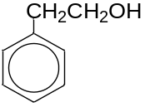
was made to react with excess alkaline potassium manganate(VII) solution.
Which of the following shows the correct structure of the product formed?
A B
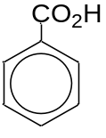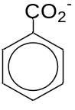

C D
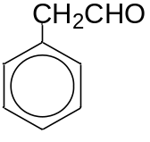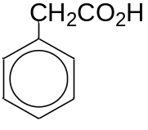

- 1 mol of PCl₅ reacts with 1 mol of compound X.
Which of the following could be X?
A HOCC₆H₄CO₂CH₃
B HO(CH₂)₂OH
C HOCH₂C₆H₄OH
D HCO₂CH₂C₆H₄CO₂H

- What are the products formed upon warming J with Tollens’ Reagent?

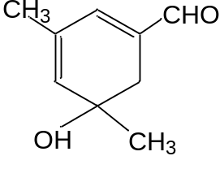

J

A Silver mirror and a carboxylic acid
B Silver mirror and a carboxylate salt
C Silver mirror, a ketone and a carboxylic acid
D Silver mirror, a ketone and a carboxylate salt

- Compounds T and U are isomers with the following structures:
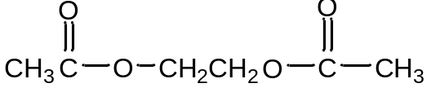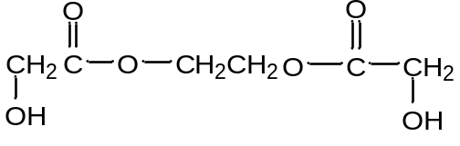
Compound T Compound U
Which of the following sets of reagents can distinguish T from U?
A 2,4-dinitrophenylhydrazine
B Alkaline aqueous iodine
C Alkaline aqueous copper(II) ions
D Phosphorus pentachloride

- 2,4-D and MCPA are two common selective weed killers, with the following structures.
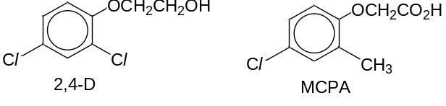
Which of the following reagents can be used to distinguish between them?
A Sodium metal
B Sodium carbonate
C Aqueous iodine in aqueous sodium hydroxide
D Hot concentrated potassium manganate(VII)

For questions 26 to 30, one or more of the three numbered statements 1 to 3 may be correct. The responses A to D should be selected on the basis of

A | B | C | D
1, 2 and 3 are correct | 1 and 2 only are correct | 2 and 3 only are correct | 1 only is correct

No other combination of statements is used as a correct response.

- Which of the following statements are true?
1 H₂S is a stronger acid than H₂O.
2 The bond angle in H₂S is larger than that in H₂O.
3 The boiling point of H₂S is higher than that of H₂O.

- The two steps involved in the conversion of compound X to compound Z are as follows:
X → Y --- Step I
Y → Z --- Step II

Y is an intermediate that could be isolated. The energy profile of the reaction is as shown below.
Energy
Reaction Pathway
X
Y
Z

Which statement correctly describes the reaction?
1 Step I occurs faster than step II.
2 Activation energy for step I is smaller than that for step II.
3 Z is thermodynamically less stable than X.

- Which sequence below shows the compounds in decreasing order of K_{a}?
1 | CH₃CF₂CO₂H | > | CH₂FCHFCO₂H | > | CHF₂CH₂CO₂H
2 | CH₂BrCO₂H | > | CH₂ClCO₂H | > | CH₂FCO₂H
3 | CH₃CH₂CO₂H | > | CH₂ClCH₂CO₂H | > | CH₃CH(OH)CO₂H

- Chlorofluorocarbons (CFCs), such as CCl₃F, are a class of chemically stable compounds and were once used widely used in daily in aerosol sprays. However in recent years, CFCs have been replaced by hydrofluorocarbons (HFCs), such as CH₃CHF₂, as CFCs contribute to ozone depletion,
Which of the following properties explain why HFCs are used?
1 They are less reactive than the corresponding chloroalkanes.
2 They may be used as aerosol propellants.
3 They are non-flammable.

- Malic acid, which occurs in apples, has the following structure.
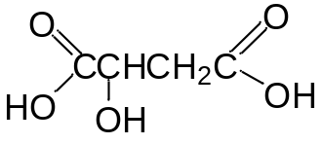
Which of the following substances will react with all the three -OH groups present in one malic acid molecule?
1 Sodium
2 Phosphorus pentachloride
3 Sodium carbonate

